**Lab report no 9**



**Fall 2022**

# Computer System Programming Lab

**Submitted By**

**Names Registration No**

# Muhammad Ali 19pwcse1801

Section: **A**

**Date**:19,2,22

**Submitted To: MAM. Madiha Sher**

Department of Computer Systems Engineering

University of Engineering and Technology, Peshawar

**Task no 1: -**

**Code: -**

#include<stdio.h>

#include<unistd.h>

#include<sys/stat.h>

#include<dirent.h>

#include<string.h>

void listdir( char *name, int level)

{

DIR *dir;

struct dirent *entry;

if (!(dir = opendir(name)))

return;

if (!(entry = readdir(dir)))

return;

do {

if (entry->d_type == DT_DIR)

{

char path[1024];

int len = snprintf(path, sizeof(path)-1, "%s/%s", name, entry->d_name);

path[len] = 0;

if (strcmp(entry->d_name, ".") == 0 || strcmp(entry->d_name, "..") == 0)

continue;

printf("%*s%s\n", level*2, "", entry->d_name);

listdir(path, level + 1);

}

else{

printf("%*s- %s\n", level*2, "", entry->d_name);

}

} while (entry = readdir(dir));

closedir(dir);

}

int main(int ar,char *v[] ){

int a=1; //levels

if (ar!=2){

printf("error: no appropriate arguments...");

return -1;

}

else{

listdir(v[1],a);

}

return 0;

}

**Output 1: -**

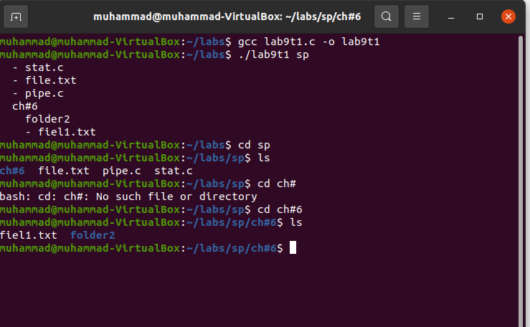

**Task no 2: -**

**Code: -**

#include<stdio.h>

#include<unistd.h>

#include<sys/stat.h>

#include<dirent.h>

void breadthfirst(char *dirname){

struct dirent *ds;

DIR *dr;

struct stat buf;

dr=opendir(dirname);

if(dr==NULL)

{

printf("%s\n",dirname);

perror("Failed to open dir\n");

}

chdir(dirname);

while ((ds=readdir(dr))!=NULL){

printf(" %s ",ds->d_name);

}

rewinddir(dr);

while ((ds=readdir(dr))!=NULL)

{

printf("%s\n",ds->d_name);

stat (ds->d_name,&buf);

if(S_ISDIR(buf.st_mode)){

if (ds->d_name[0]!='.'){

breadthfirst(ds->d_name);

chdir("..");

}

}

}

}

int main(int ar, char * v[]){

if (ar!=2){

printf("error: no appropriate arguments...");

return -1;

}

else{

breadthfirst(v[1]);

}

return 0;

}

**Output 2: -**

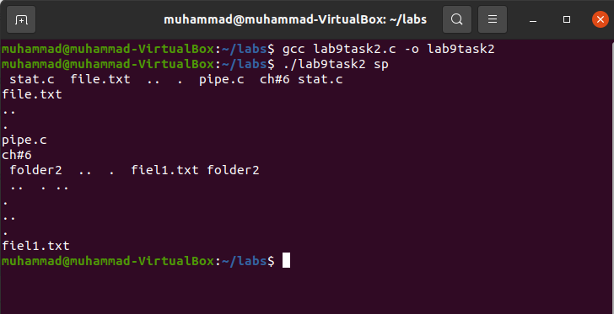

**Task no 3: -**

#include<stdio.h>

#include<stdlib.h>

#include<unistd.h>

#include<sys/stat.h>

#include<dirent.h>

#include<string.h>

void depthfirst(char *dirname,char * filename){

struct dirent *ds;

DIR *dr;

struct stat buf;

dr=opendir(dirname);

if (dr==NULL){

perror("failed to open: ");

}

chdir(dirname);

while ((ds=readdir(dr))!=NULL){

stat (ds->d_name,&buf);

if (!strcmp(ds->d_name,filename)){

printf(" file '%s' is availible in given directry..\n",filename);

exit(0);

}

if(S_ISDIR(buf.st_mode)){

if (ds->d_name[0]!='.'){

depthfirst(ds->d_name,filename);

chdir("..");

}

}

}

closedir(dr);

}

int main(int ar, char * v[]){

if (ar!=3){

printf("program required two argument...");

}

else

{

depthfirst(v[1],v[2]);

}

return 0;

}

**Output 3: -**

